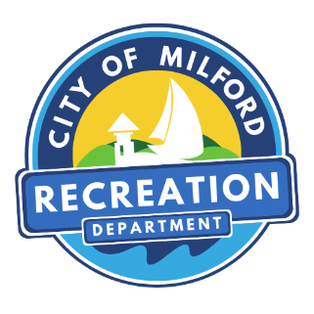

City of Milford, Connecticut
--Founded 1639 -
70 West River Street | Milford, CT 06460-3317
Tel 203-783-328 | Fax 203-783-3284
www.milfordrecreation.com

MILFORD WALKERS

A FUN BEGINNER / INTERMEDIATE WALKING GROUP. We walk three miles Tuesdays & Fridays from 10:00am-11:00am. (Part June, July & August 9-10am.) Everyone is welcome to join.

Tuesday | 3/3/26 | 10:00 am | North Street & Hitching Post Lane by the Duck Pond
Friday | 3/6/26 | 10:00 am | Behind the library, New Haven Ave
Tuesday | 3/10/26 | 10:00 am | Silver Sands State Park
Friday | 3/13/26 | 10:00 am | Hawley Avenue Playground  Corner of Wall St and Beach Ave
Tuesday | 3/17/26 | 10:00am | Tri-Beach Rec Center, next to Bonfire Grille
Friday | 3/20/26 | 10:00 am | Court Street by the tennis courts.
Tuesday | 3/24/26 | 10:00 am | Margaret Egan Center
Friday | 3/27/26 | 10:00 am | Gulf Beach, by the hot dog stand.  If you aren’t a resident, park accordingly.
Tuesday | 3/31/26 | 10:00 am | Walnut Beach at the end of Viscount Dr., If you aren’t a resident, park accordingly.

*Have an idea for a new walk? Let us know and we will add it to the schedule*
For more information: Contact Bob Hayes 203-783-3283 or rhayes@milfordct.gov
Bad Weather – Walk Cancelled

